

**Student Information Pack**

**Cheltenham General Hospital**

**Recovery**

Contents

Welcome and Introduction 3

Shifts, Contacts, Sickness and Uniform 3

Orientation 4

Initial Discussion 5

Learning Enviroment 5

Placement Schedule 7

Objectives of Induction 7

Preparation of Recovery 8

Admission to Recovery 8

ABCDE Assessment and Documentation 8

Ward Handover Guidance 10

Care Plans 11

Interventions 16

Activities 17

# Welcome and Introduction

Welcome to your placement in Recovery, in this booklet you will find useful information on types of surgery undertaken in theatres, our role as recovery nurses, documentation, and information about our trust.

You will be assigned one practice assessor and you will also be able to work with multiple practice supervisors, our aim is for you to learn from different individuals and gain insight on our role as recovery nurses.

We hope to help you feel part of the team and find your time with us useful and enjoyable.

Practice assessor:

Practice supervisor:

# Shifts, Contacts, Sickness and Uniform

**Shift Pattern**

We do 10 hours shifts with varying starting times, you will be allocated to work with your practice assessor or supervisor as much as possible, and in the case this is not possible you will be allocated to work with another member of staff.

**Contact**

Recovery 03004224142 and 03004222519

**Sickness**

In case of sickness please contact recovery as soon as possible and speak to your practice assessor, supervisor or a Sister. Please ensure you have notified the University of your absence.

**Uniform**

Please read the Trust uniform policies or speak to the ward manager.

# Orientation

Recovery is within the theatre area and close to the 2 day units (Chedworth and Kemerton).

Recovery is where care is provided post-surgery. It is an area, usually attached to the operating theatres, designed specifically to provide care for patients recovering from surgery and anaesthesia, whether it be general, regional or local anaesthesia. A significant part of the care relates to surgical nursing care, e.g. management of drains, irrigation, but also includes nevertheless a lot of airway and pain management.

Nurses and operating department practitioners (ODPs) undertake essential care for these patients including:

* Airway management.
* Monitoring vital signs (heart rate, blood pressure, respiration, etc.)
* Managing postoperative pain.
* Post op wound management.
* Treating symptoms of postoperative nausea and vomiting (or PONV)

These common activities often need supplementing with more intensive treatments including:

* Preparation and establishment of patient controlled analgesia (PCA) pumps.
* Preparation and establishment of epidural infusions.
* Preparation of epidural infusions
* Management of invasive monitoring such as arterial lines and central venous lines.
* Occasionally treating serious life threatening complications, such as laryngospasm or respiratory arrest that can arise post-anaesthesia. Recovery staff must be trained and experienced in the immediate management of these situations where the patients airway is compromised.

Unless complications occur and once achieving discharge criteria , most patients will only stay in recovery for a short period of time before returning to another department in the hospital.

# Initial Discussion

We would like to know more about you to understand your motivations, your career projection, your goals and aims and to be able to support you during your placement in recovery.

In order to get to know you we would like you to answer a few informal questions and do a learning questionnaire to be able to adjust our teaching style to your preferred learning style.

**Informal discussion**

* Why did you decide to do your course ?
* Which other placements have you done?
* Which placement did you like more and why?
* What motivates you?
* What do you think we do in recovery?
* What do you expect to learn during your placement?

**Honey and Mumford learning Styles Questionnaire**

Please follow this link and complete the questionnaire. , It will help us tailor our teaching to your learning style.

<https://www.mint-hr.com/mumford.html>.

# Learning Enviroment

Theatres in Cheltenham General Hospital are divided in three different areas with their own recovery. General Theatres(6 theatres), Orthopaedic Theatres(4 theatres), Eye Theatres(2 theatres). The members of the team will be allocated to each area depending on the staffing requirements skill mix, the layout of the bays are the same in the three areas and you will be shown around when you are allocated to each of them.

# Objectives of Induction

* Accept a patient from theatres (day case), receive an anaesthetic handover and manage that patient’s care.
* Conduct a comprehensive ABCDE assessment of the post-op patient and respond appropriately to any issues that arise.
* Reassure the patients, make them feel safe in vulnerable situations.
* Work effectively as a member of the multi-disciplinary theatre team
* Work safely within governing body regulations and trust policy.
* Provide an accurate record of care given within the recovery area and hand over the information to the ward to continue the ongoing patient care.

# Preparation of Recovery

To assure the safety of both patients and staff we complete daily, weekly and monthly checks for the bays, equipment and medication in recovery.

You will find a folder in each recovery (General, Orthopaedic and Eyes) that details all the checks and a space to sign when they have been completed.

Some of the checks include making sure your suction, O2 and Waters Circuit are all functioning appropriately and making sure your defibrillator trolley is correct and ready to go. We would like to encourage you to join in with the checks and familiarise yourself with our equipment.

# Admission to Recovery

Theatres should always call when they are bringing out a patient so you should have time to prepare. Make sure you are wearing an apron, gloves, mask and in the case of an airway devide make sure you are also wearing eye protection. Know which bay you would like to go to and guide theatres to the correct bay.

Plug the monitor in and connect the patient to the O2 mains, then take handover from the anaesthetists. The scrub staff should also come out from theatres to give you a handover.

If the patient has an airway prepare your suction and a Hudson mask and wait for the patient to wake up for you to remove the airway. While you are waiting for the airway to be rejected if you feel confident enough you could start an initial ABCDE assessment.

# ABCDE Assessment and Documentation

The current recovery care plan consists of a checklist to be completed on arrival to recovery and on discharge from recovery. Anything not covered in the checklists should be documented in the extra pages supplied.

When doing your ABCDE assessment here are some things to consider:

**Airway**

* Is the airway patent? Is the patient maintaining their own airway?
* What type of airway device has the patient got (e.g. LMA / Guedel) and is it working effectively? Are they requiring assistance such as a jaw thrust or chin lift to maintain their airway?
* If the patient’s airway is obstructed or compromised what is the cause and what actions were taken to secure the airway?

**Breathing**

* Is the patient breathing spontaneously (self-ventilating) or is mechanical ventilation required? If the patient has needed an intervention to aid their breathing, what was it and was it effective
* What is the respiratory rate?
* Is the breathing from abdomen/chest? Is it paradoxical or ‘see saw’ which could be a sign of obstruction.
* Is breathing shallow/equal/bilateral/laboured? Is the patient using their accessory muscles?
* Any sounds noted (wheeze/stridor/rattling)
* What percentage of oxygen is being delivered to the patient and how? What are their oxygen saturations?

**Circulation**

* Document the blood pressure and how it is measured. Is it invasive or non-invasive?
* If your patient is hypotensive have you taken action to reverse this? Any review or intervention should be documented.
* Document the heart rate. Are they in sinus rhythm? If they are tachycardic, bradycardic or having arrhythmias, is this normal for the patient?
* Document if the anaesthetist has reviewed any concerns and any interventions made.
* Fluid input and output. (In case of drains, a stoma, hourly catheters or patients with high dependency)
* IV access. Document type of access, insertion site and that the cannula has been flushed in recovery.
* IV fluids and other infusions.
* Drains. Document number, type, output volume and location. Record if they are leaking or clamped (and time to be unclamped). If there is a pack in situ, also document this and check that the patient has a pink wristband and a care plan.
* Any signs of circulatory collapse, check CRT.
* Blood loss that could compromise a patient’s circulation.

**Disability**

* Document your patient’s level of consciousness on arrival to recovery using AVPU. If a more detailed assessment is required then GCS can be measured.
* What is the patient's blood sugar (if it needs to be taken)?
* Are pupils equal and reacting to light? (Can be assessed if your patient is unconscious and difficult to rouse.)
* If the patient has post op delirium what actions were taken (e.g. Chemical restraint).

**Exposure**

* Temperature and any actions that you have made to warm /cool the patient.
* Check surgery site - document the number, location and type of dressings and if there is strike through or oozing. Document any interventions made.
* Pain and Nausea score, and any action taken to improve this.
* Motor and sensory block checks. (Document neurovascular observations for orthopaedic patients)
* Mechanical DVT prophylaxis (calf or foot garments)
* If there is an epidural in situ? Is it providing effective pain relief? What is the block level and motor score? Any other ongoing infusions for pain. What monitoring are you doing for these? (Complete Pain chart).
* Document when pressure areas have been checked including waterlow and if further pressure area care is required. Record any rashes or broken pressure areas that you find. Consider implementing skin bundle if skin is vulnerable and patient has high waterlow.
* ABG and review. Any other post-op bloods that have been requested.
* Does the patient require a prolonged or overnight recovery?
* When the next review is due (if necessary) and by whom.

Always make sure you document any and every action you take for the patient.

# Ward Handover Guidance

* Patient name, age and surgical procedure undertaken
* Surgeons post op plan from the operation note, including discharge date and outpatient appointment.
* Patient past medical history including allergies
* Type of anaesthetic given (general, regional or local) any relevant drugs and fluids given intra operatively.
* Any significant events during anaesthesia that are relevant to the patient's stay on the ward
* Summary of the patient recovery. Include any interventions (eg. analgesia or anti- emetics) and any significant events that would inform the ward regarding ongoing care.
* NEWS and pain score
* Medication prescribed – ensure PRNs available for pain and nausea make sure TTOs are signed.
* Any ongoing treatment such as PCAs/epidurals, IV infusions, drains and urinary catheters

# Care Plans

We have completed the most common care plans used in recovery as an example as what you might find during your time with us.

* **NEWS Chart**
* **Pain management chart**
* **Neurovascular Observations Chart**
* **24 Hour Fluid Balance Chart**

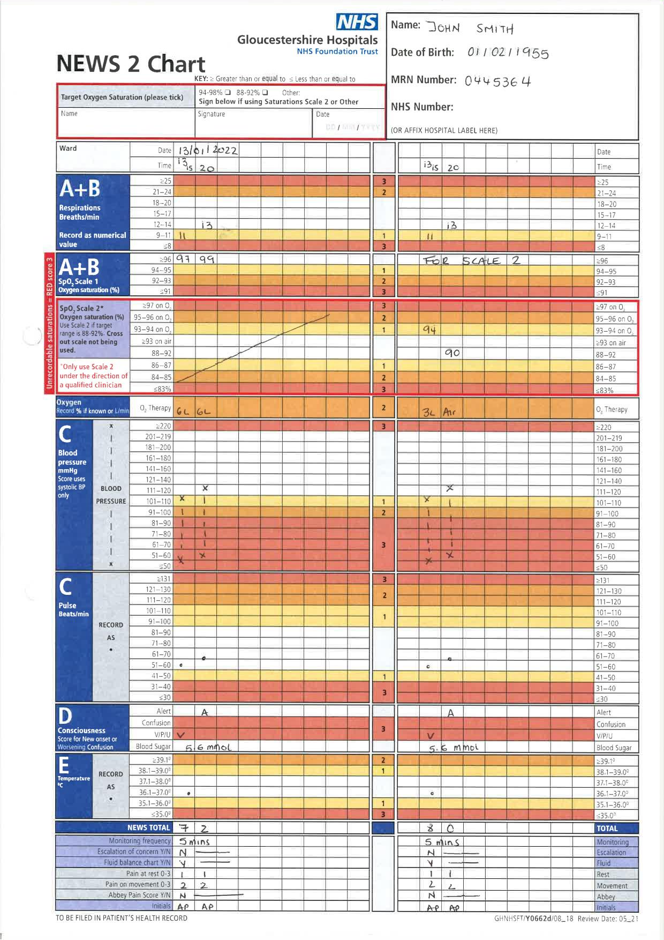

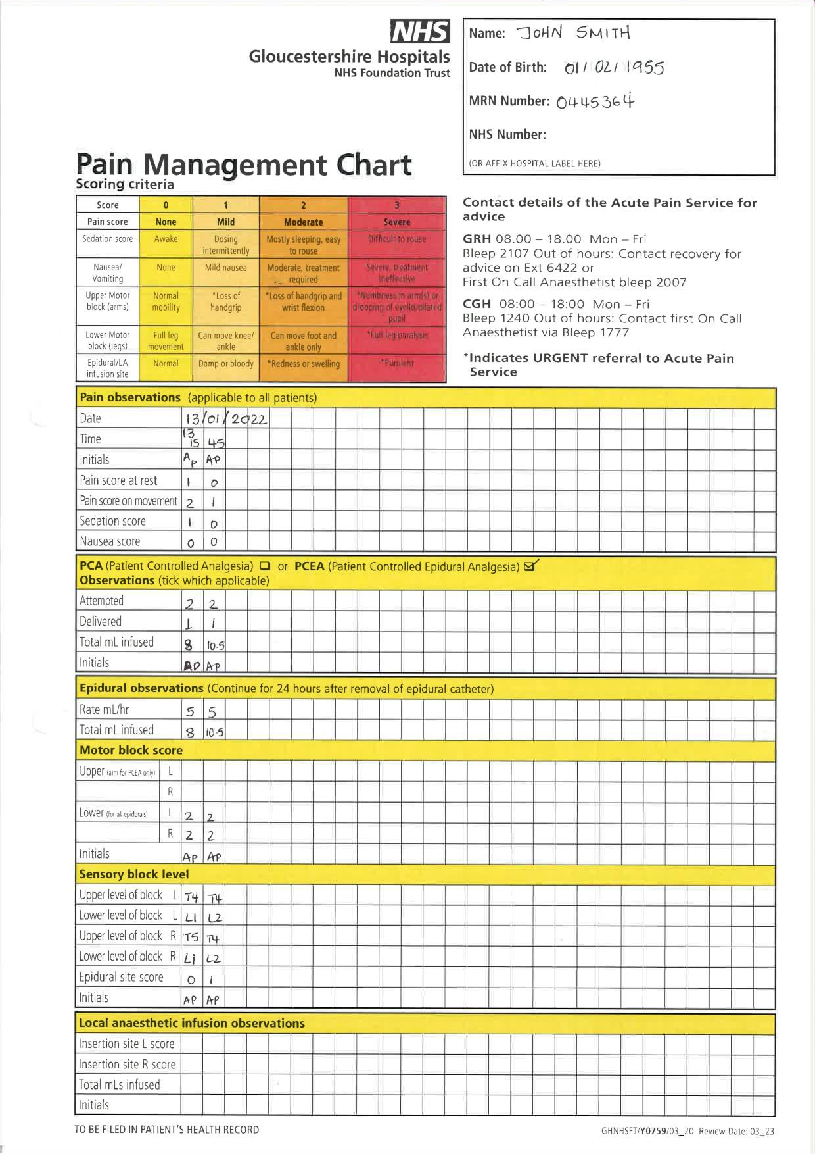

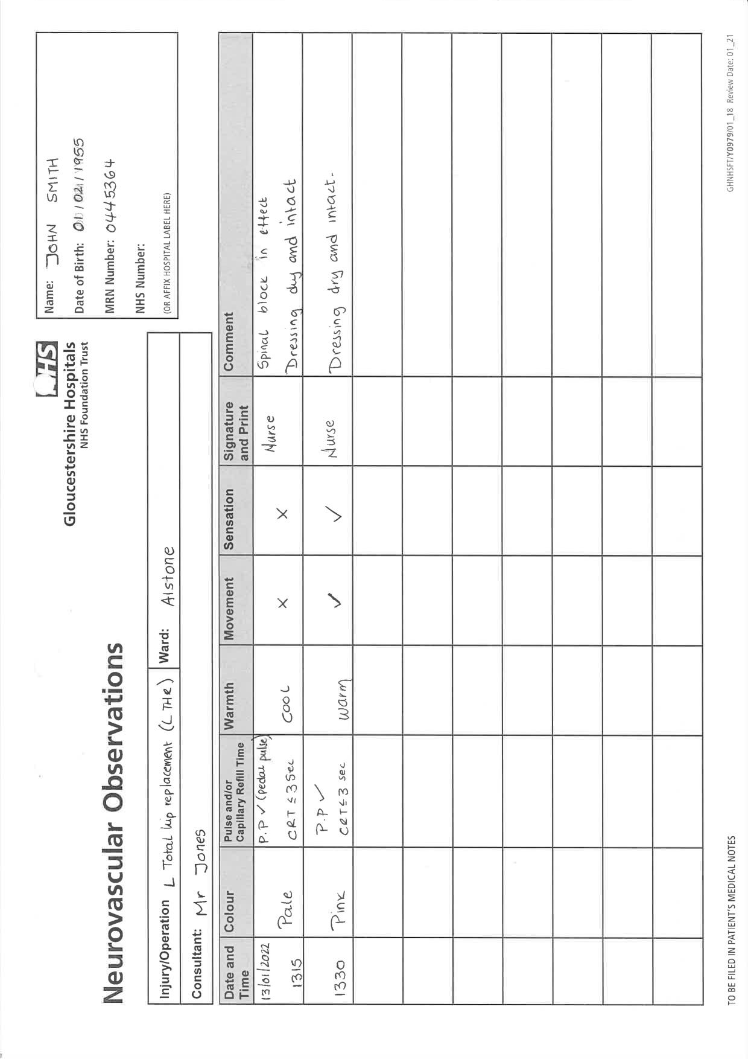

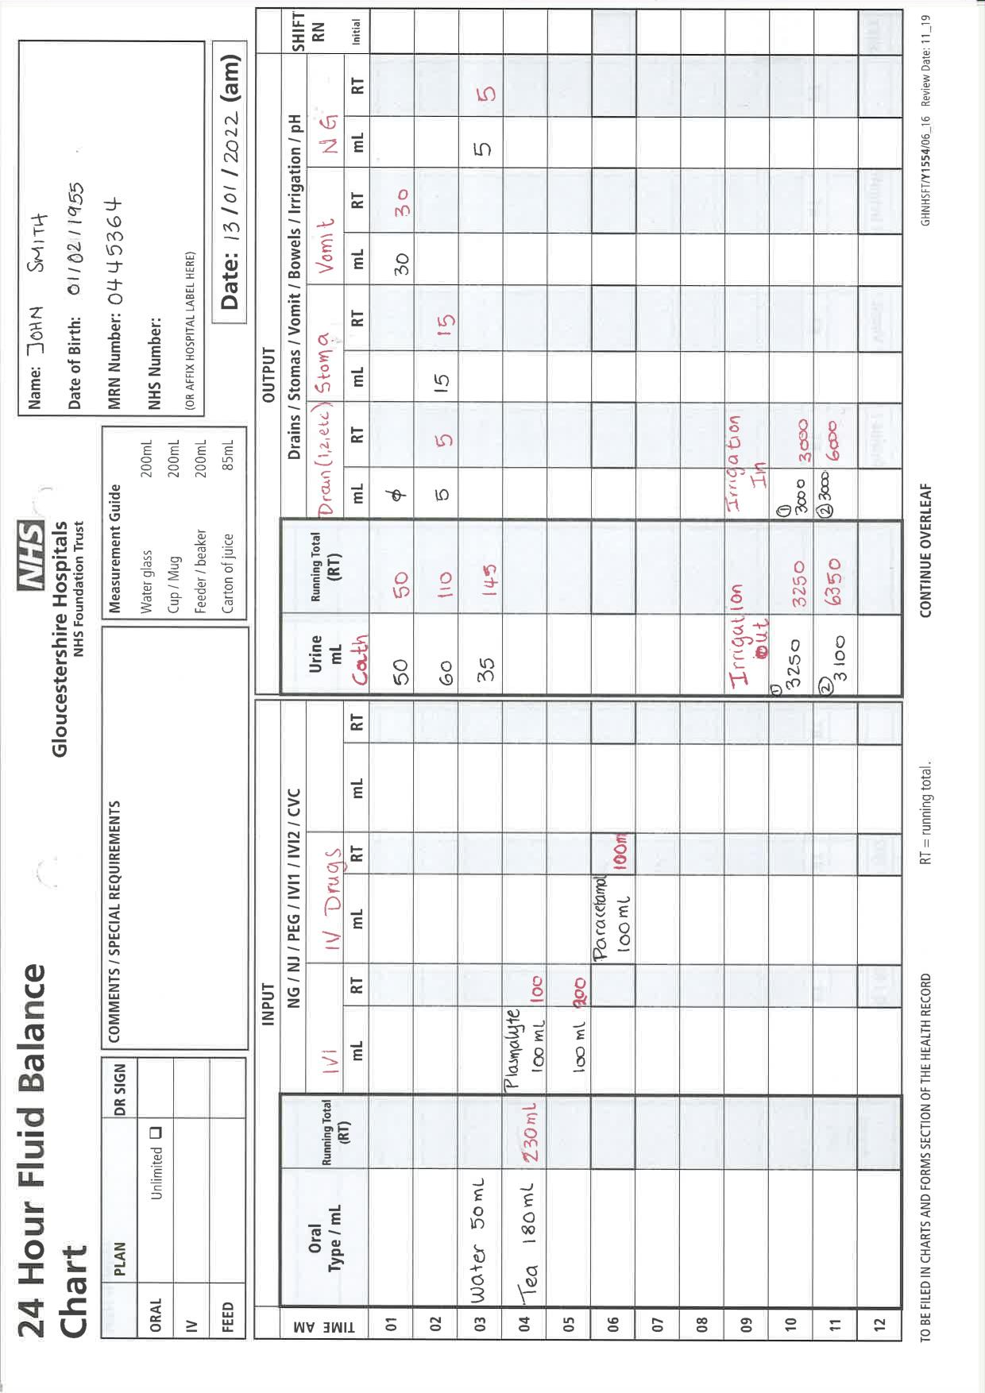

# Interventions

At Cheltenham General you can expect to come across the following specialities:

* Lower Gastrointestinal
* Gynaecology/upper, bariatric
* Breast
* Orthopaedics
* Urology
* Ophthalmology

There are certain checks that should be done that are specific to the speciality of the surgery. You can find a brief list pertaining to each speciality below:

**Lower Gastrointestinal**

* Check wound site for bleeding.
* Make sure the abdomen is soft and not extended.
* Observe for PR bleeding.
* Watch drain for excessive drainage, clamps, colour of drainage.
* Check stoma colour, bleeding, warmth.
* Check NG tube position and drainage.

**Gynaecology**

* Observe wound site for bleeding, swelling, hardness.
* Observe for PV bleeding
* If there are drains in situ, monitor output, if clamped ask when they need to be released
* Some gynaecological procedures can cause a lot of pain and anxiety, observe and treat appropriately.

**Breast**

* Check operation site on admission to recovery as a baseline and then again on discharge to ensure there is no haematoma or bleeding.
* If there is a drain, make sure it is unclamped and draining and if it’s clamped ask what time it can be unclamped.
* Patients may be blue in skin colour that is due to the dye injected for the procedure.

**Orthopaedics**

* Check operation site and keep dressings on even if the wound is bleeding and add extra padding unless specified otherwise by the surgeon
* If there are drain in situ monitor drainage. If they are clamped check what time they are to be released.
* Elevate the limb if requested or place brace/ sling in place.
* All orthopaedic patients must have neurovascular observations completed.
* Knee and hip replacements should all have flowtron pumps in situ unless specified otherwise by the surgeons.
* Check when the next dose of antibiotic is due.
* If CPM (continuous passive movement) machine is required please contact ward physiotherapist.

**Urology**

* Check operation site on admission to recovery as a baseline and then again on discharge to ensure there is no bleeding.
* If there is a catheter make sure it is draining well, check the colour and bleeding.
* Patients will feel they need to pass urine due to the catheter causing bladder spasms, you can give Buscopan to help with the spasms. It is a normal sensation most patients will get.
* If the patient has Mitomycin C in situ the catheter will be clamped, and you will have to release it at the time the surgeon specifies.
* In case of irrigation ensure it is warm Sodium Chloride 0.9%. Titrate according to urine colour. Make sure you keep an accurate fluid chart with irrigation input and output.
* TURP syndrome can sometimes occur in patients with irrigation. Symptoms can include dizziness, nausea, shortness of breath, confusion, restlessness, increased or decreased BP, lowered HR. Slow the irrigation, administer oxygen and call for the anaesthetist.
* After a Robotic Prostatectomy due to being positioned head down intra op for a prolonged period the patient might suffer from confusion, facial oedema and disorientation which should all subside with time.

**Ophthalmology**

* Observe eye for bleeding/oozing.
* Ensure patch/guard in situ if needed.
* Some patients can are only permitted to sleep in specific positions after the operation. Make sure the paperwork is completed and handed over to the ward staff.

# Activities

**Activity 1**

Find out the most common drugs used in recovery and do a search using the BNF.

**Activity 2**

We use arterial lines to closely monitor blood pressure on some of our patients, do some research on how they work, uses, risk, etc.

Training on how to prime the set and explanation of arterial line trolley.

**Activity 3**

There are many ways of treating pain and we would like you to do some research on our most used pumps in recovery: PCA, Epidural/PCEA and rectus sheath.

Where are they placed? How does it work? Which are the side effects?

**Activity 4**

Blood transfusions are often needed during a procedure or after, as nurses we are responsible in administering any blood products prescribed by the anaesthetist.

Do you know why it is important to know the patient’s blood group and which blood type could be administered? Do some research on transfusions, blood groups and how it is identified.

<https://educationalgames.nobelprize.org/educational/medicine/bloodtypinggame/gamev3/index.html>

(Please show bloodhound and our fridge)

**Activity 5**

DCC Study case

Mr J, 56 years old ,attended theatres to undergo a laparoscopic right nephrectomy which due to complications let to an open procedure. Mr J has been admitted to recovery at 1500.

Mr J is a known diabetic, hypertensive, with well control asthma, otherwise he is fit and well with no known allergies.

Mr J has two cannulas on the left arm with IV Plasmalyte running (fourth bag, two more are prescribed), an arterial line in situ and a catheter.

For pain relief Mr J has a levobupivacaine + 4 mcg of fentanyl epidural running from theatre and rescue fentanyl prescribed on the front of the drug chart.

The parameters set by the anesthetist are: spO2 > 94%; MAP > 70; sBP > 120; Urine output > 30mls/h.

The anesthetist asks you to do a blood gas, full set of bloods and a rotem.

During anaesthetic handover we observe that Mr J is clammy, pale and in pain.

1. *What initial interventions would you take.*
2. *Looking at the blood gas, what actions would you take?*
3. *When assessing the epidural block, you discover that the block is uneven. Are you able to correct it? If yes, in what way?*
4. *Mr J is now beginning to feel sick and you notice the blood pressure has dropped (85/42 mmHg, MAP 55 mmHg). What do you suspect has happened to Mr J?*
5. *Is there anything you need to reassess?*

**Activity 6**

Do you feel ready to pass on all the knowledge you have gained during your placement? Imagine you have a colleague starting their placement today, would you be able to put a little guide together to help them?